HW04_XU ZHANG_DSO545

Xu Zhang

March 5, 2018

setwd("C:/Users/Xu Zhang/Desktop/DSO545")  
load("hubwaytrip2012.rda")  
library(lubridate)

##   
## Attaching package: 'lubridate'

## The following object is masked from 'package:base':  
##   
## date

library(dplyr)

##   
## Attaching package: 'dplyr'

## The following objects are masked from 'package:lubridate':  
##   
## intersect, setdiff, union

## The following objects are masked from 'package:stats':  
##   
## filter, lag

## The following objects are masked from 'package:base':  
##   
## intersect, setdiff, setequal, union

library(ggplot2)

1. Use functions from dplyr and lubridate to summarise by Day and Start Time (Hour of the day) of bike rental usage. Save your new dataframe in a variable called trips2012Time, and output head(trips2012Time) to show the first few observations of the new dataframe. (Make sure to set the timezone to “EST”)

trips2012$start_date=mdy_hm(trips2012$start_date)  
trips2012$start_date=force_tz(trips2012$start_date,"EST")  
trips2012Time=trips2012 %>%  
 mutate(Day=wday(start_date,label=TRUE,abbr=FALSE),  
 Start_time=hour(start_date)) %>%  
 group_by(Day,Start_time) %>%  
 summarise(count=n())  
head(trips2012Time)

## # A tibble: 6 x 3  
## # Groups: Day [1]  
## Day Start_time count  
## <ord> <int> <int>  
## 1 Sunday 0 1384  
## 2 Sunday 1 1607  
## 3 Sunday 2 1660  
## 4 Sunday 3 284  
## 5 Sunday 4 128  
## 6 Sunday 5 148

1. Create the following heatmap , use color #e5f5e0 and #31a354. Summarise what you see.

ggplot(trips2012Time,aes(x=Day,y=Start_time,fill=count))+  
 geom_tile()+  
 scale_fill_gradient(low = "#e5f5e0",high ="#31a354",guide = FALSE)+  
 labs(title="Heatmap of Hubway Bike Rental Day V.S. Hour",x="",y="Hour of the Day")+  
 scale_y_continuous(breaks = seq(0,24,1))

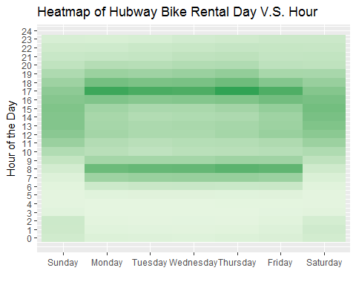

People rent bike more on weekdays than on weekends. People rent bike more on 7:00 AM to 9:00 AM and 4:00 PM to 6:00 in a day than other time.